

S.S.SRI ISWARYA

SARANATHAN

COLLEGE OF ENGINEERING

**NAAN MUDHALVAN**

NETWORK ENGINEERING

232081

ECE

11 -1 3

PTSA-3

●

PTSA-2

●

PTSA-1

●

16 - 17

MODULES

●

14 - 15

MODULES

●

MODULES

●

8 - 10

MODULES

●

4 - 7

MODULES

●

1 - 3

MODULES

●

TABLE OF CONTENT:

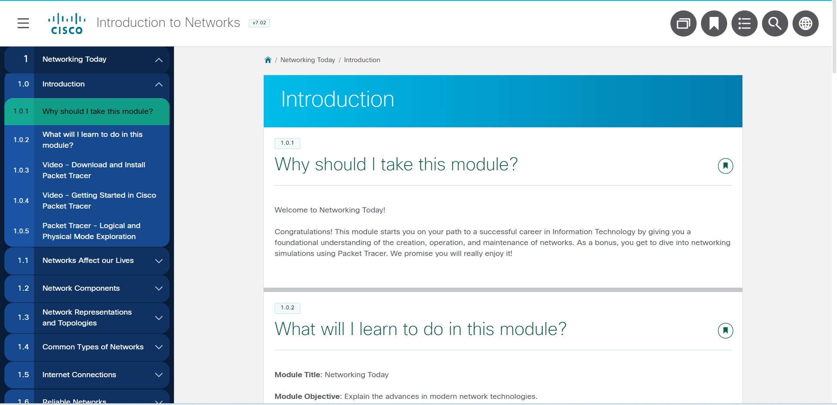

MODULES 1 - 3: BASIC NETWORK CONNECTIVITY AND

COMMUNICATIONS.

MODULE

1: NETWORKING TODAY

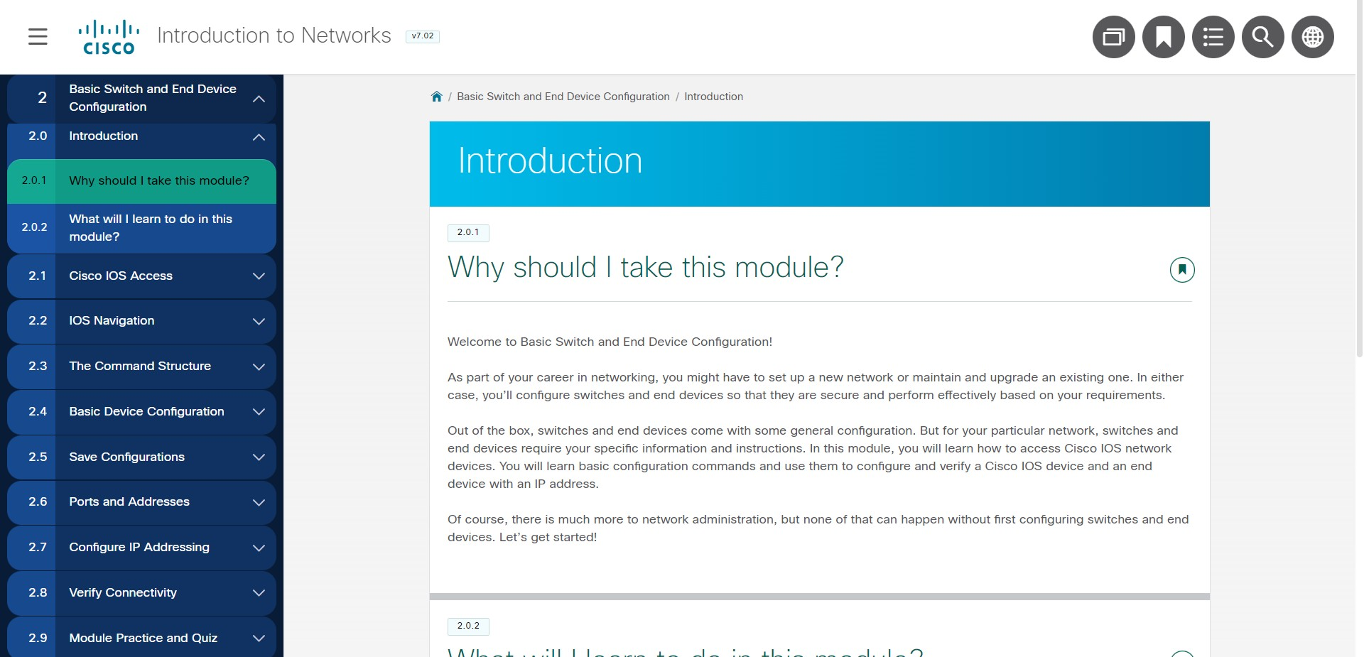

MODULE

2:

BASIC SWITCH AND END DEVICE

CONFIGURATION

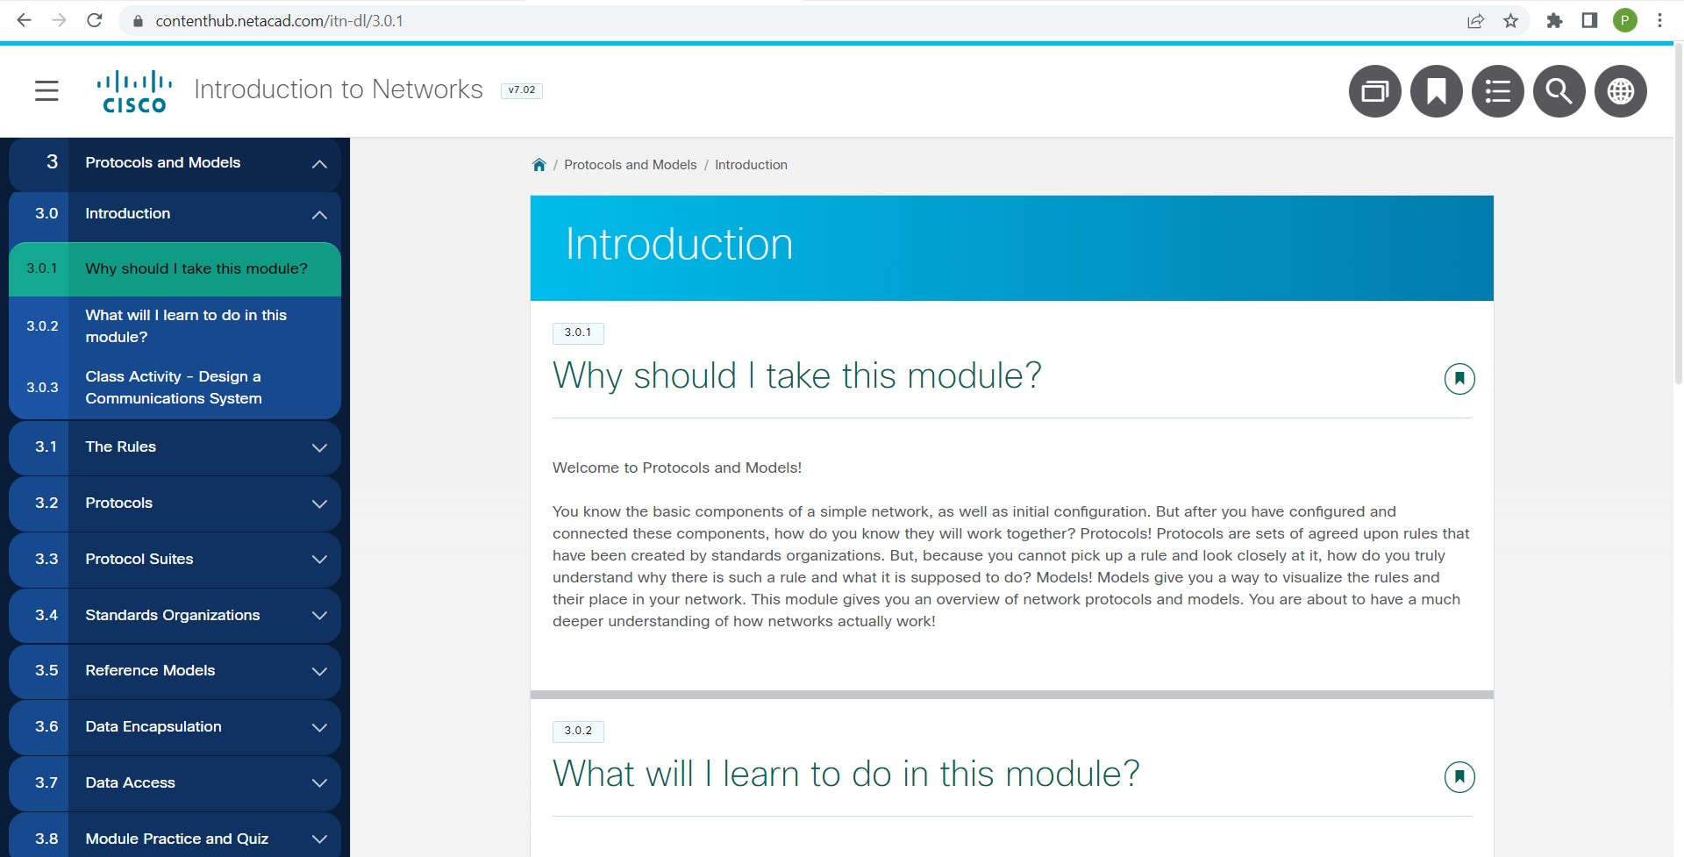

MODULE 3: PROTOCOLS AND

MODELS

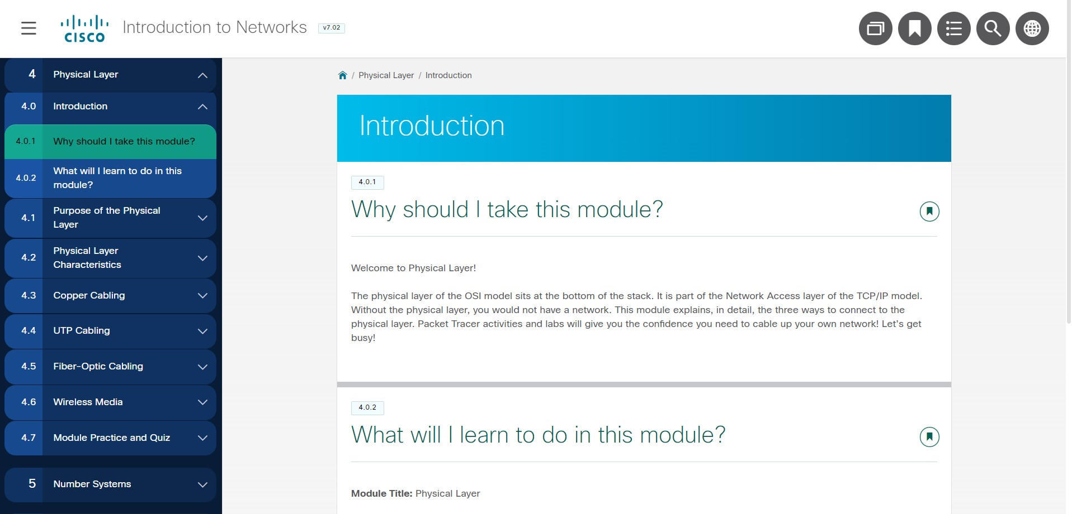

MODULES 4 - 7: ETHERNET CONCEPTS

MODULE

4:

PHYSICAL LAYER

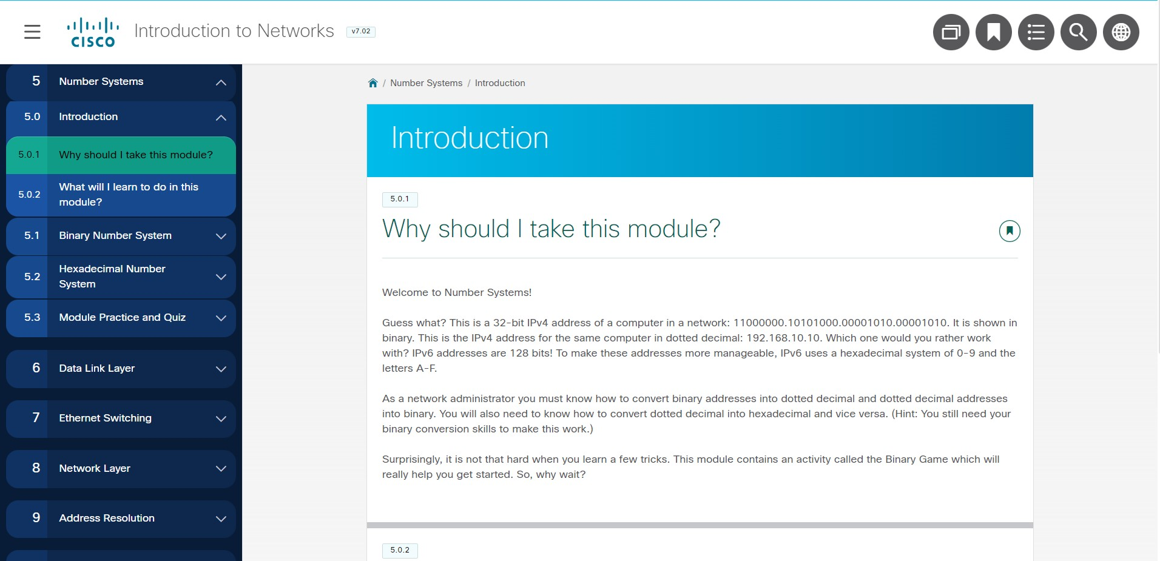

MODULE

5

: NUMBER SYSTEMS

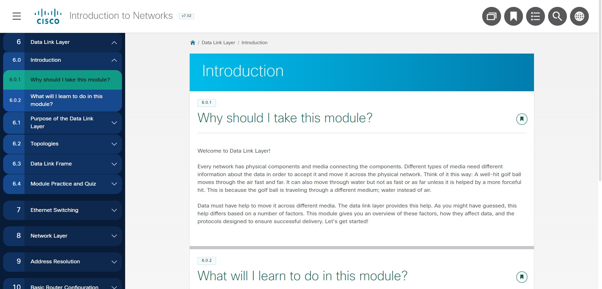

MODULE 6: DATA LINK LAYER

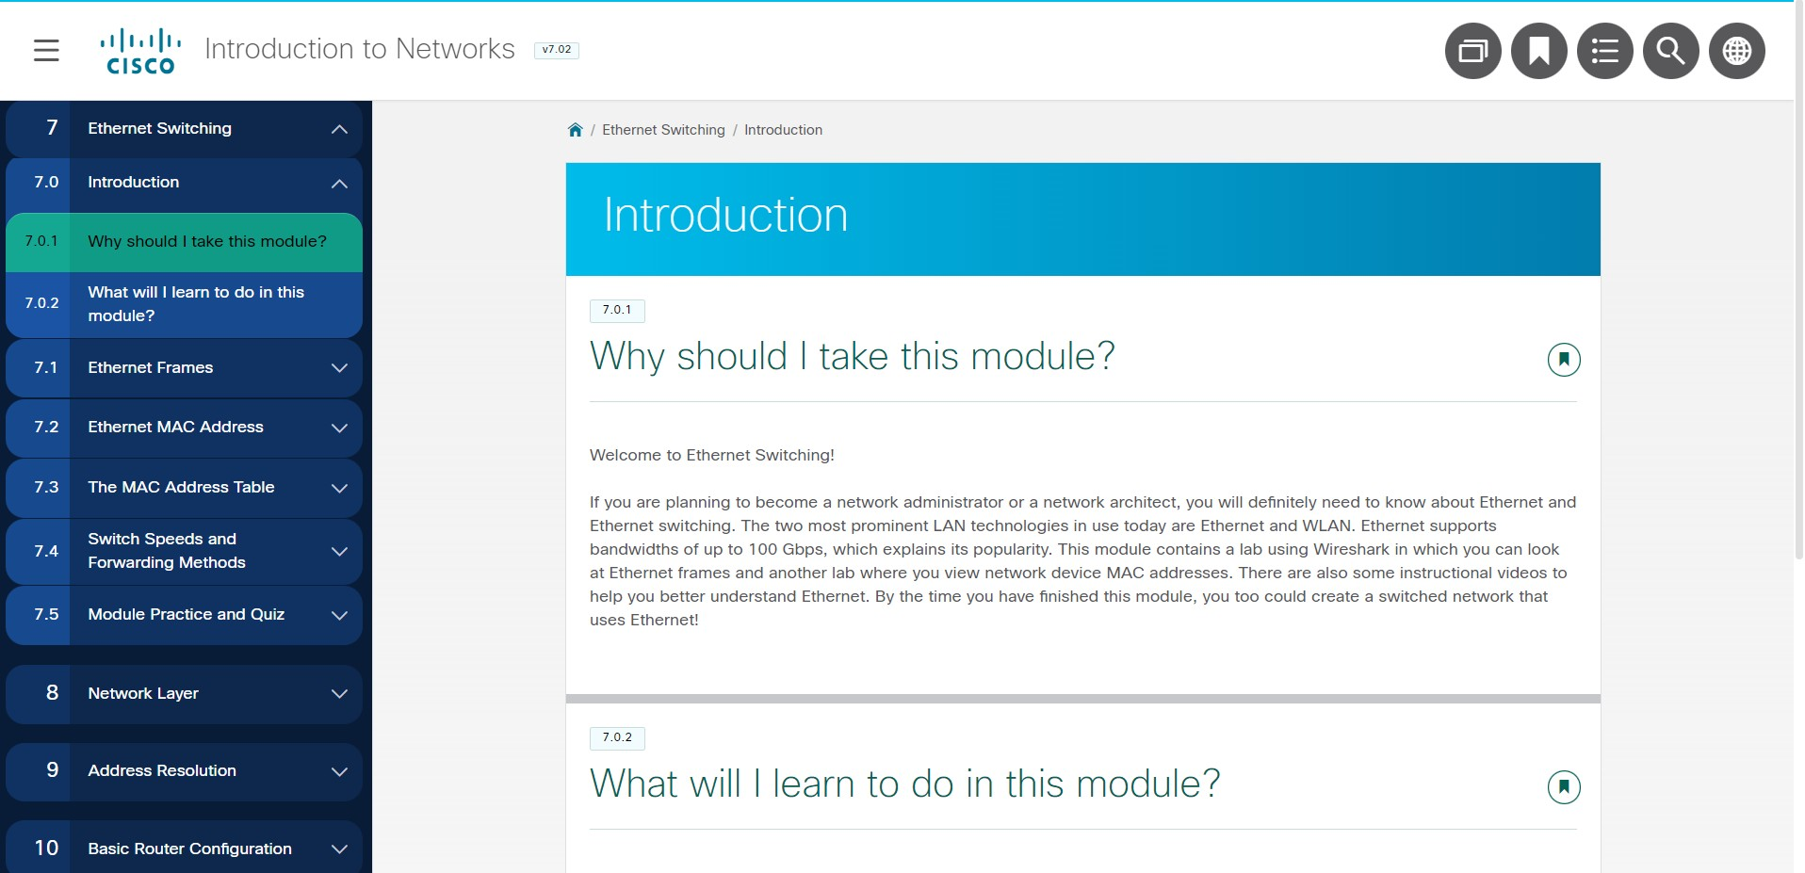

MODULE

7:

ETHERNET SWITCHING

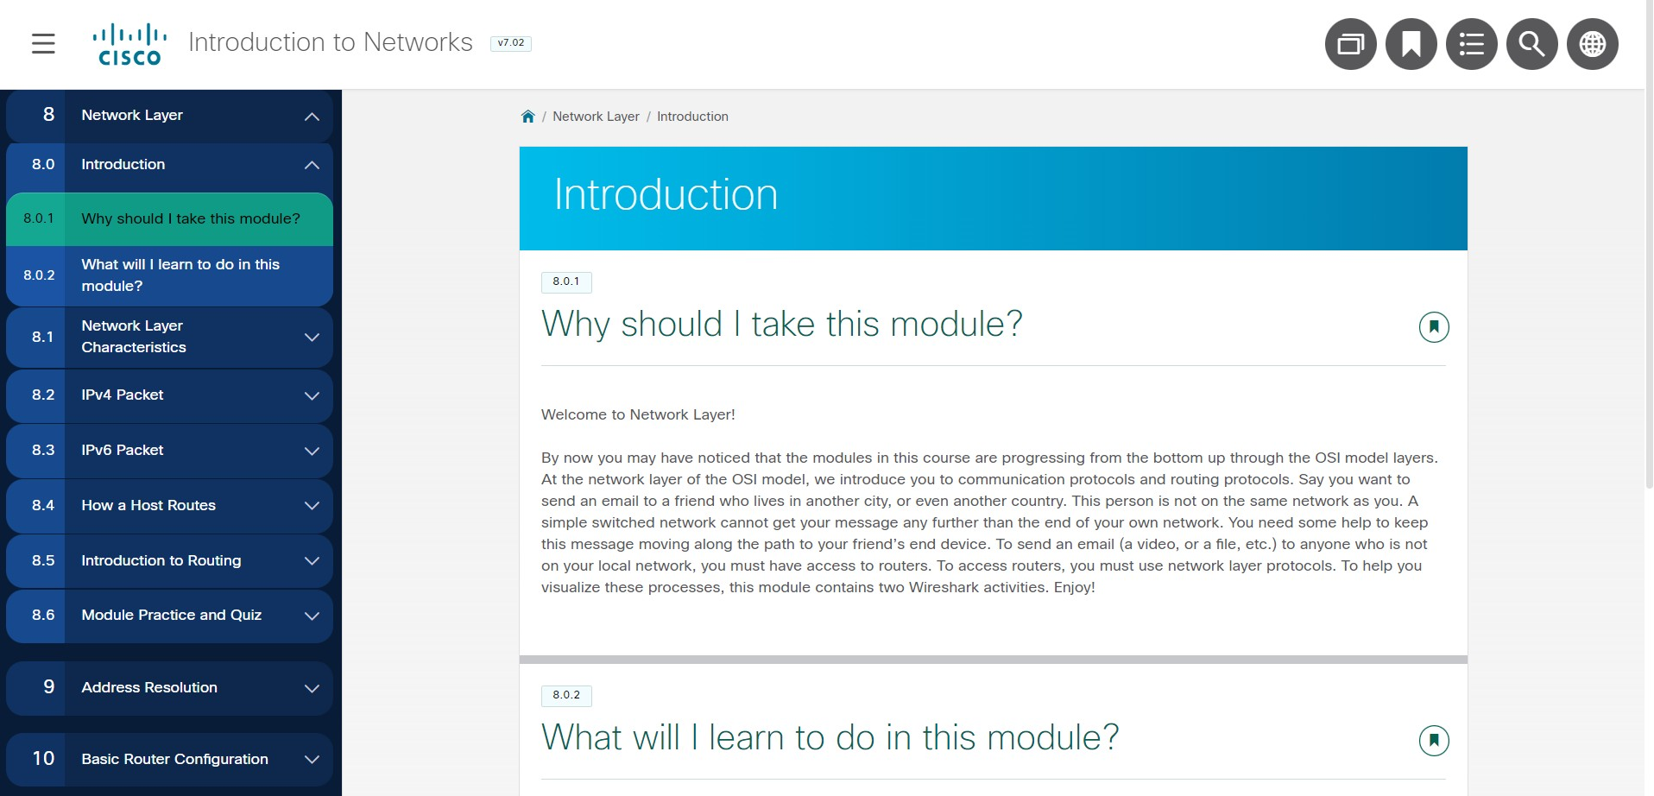

MODULES 8 - 10: COMMUNICATING BETWEEN

NETWORKS

MODULE 8: NETWORK LAYER

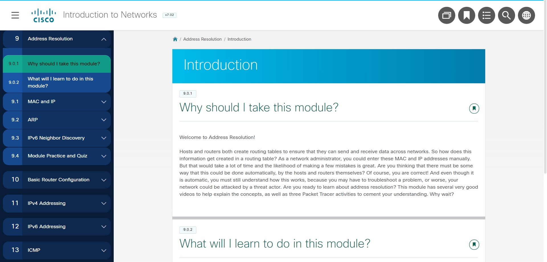

9:

MODULE

ADDRESS RESOLUTION

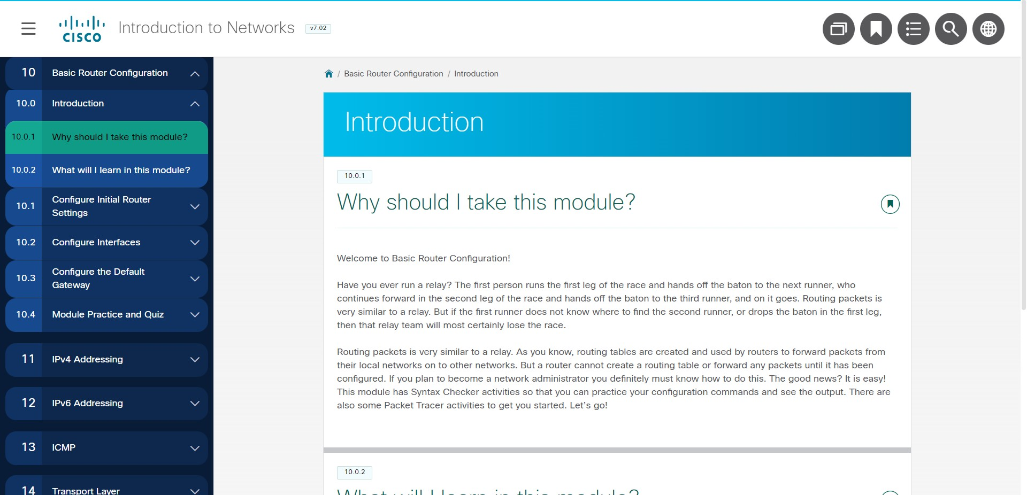

MODULE

10: BASIC ROUTER

CONFIGURATION

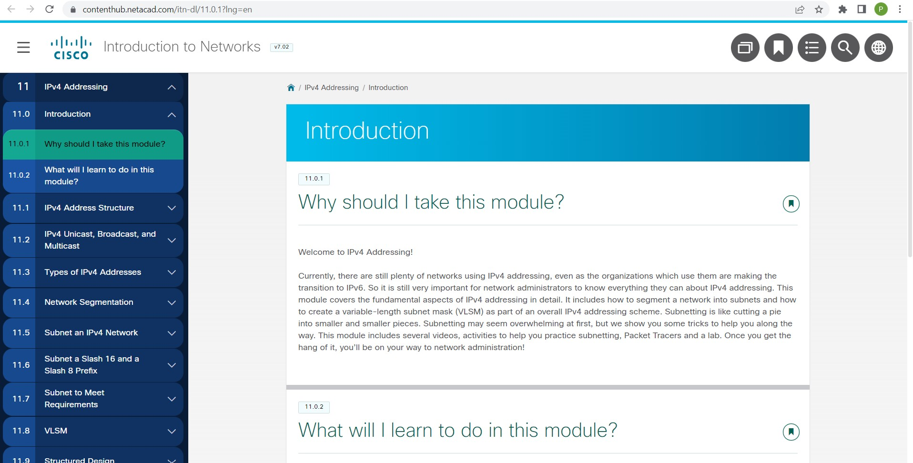

MODULES 11 - 13: IP

ADDRESSING

MODULE

11

: IPv4 ADDRESSING

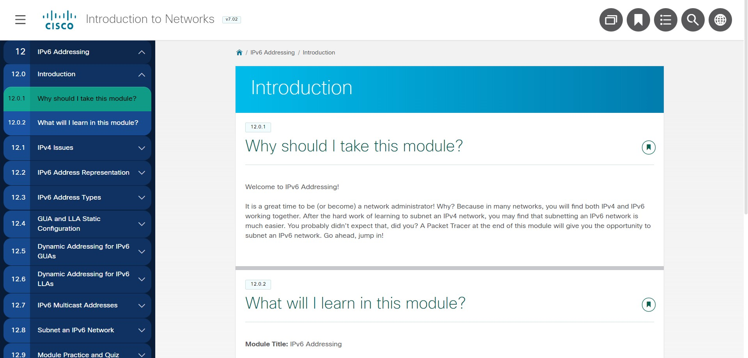

MODULE

12: IPv6 ADDRESSING

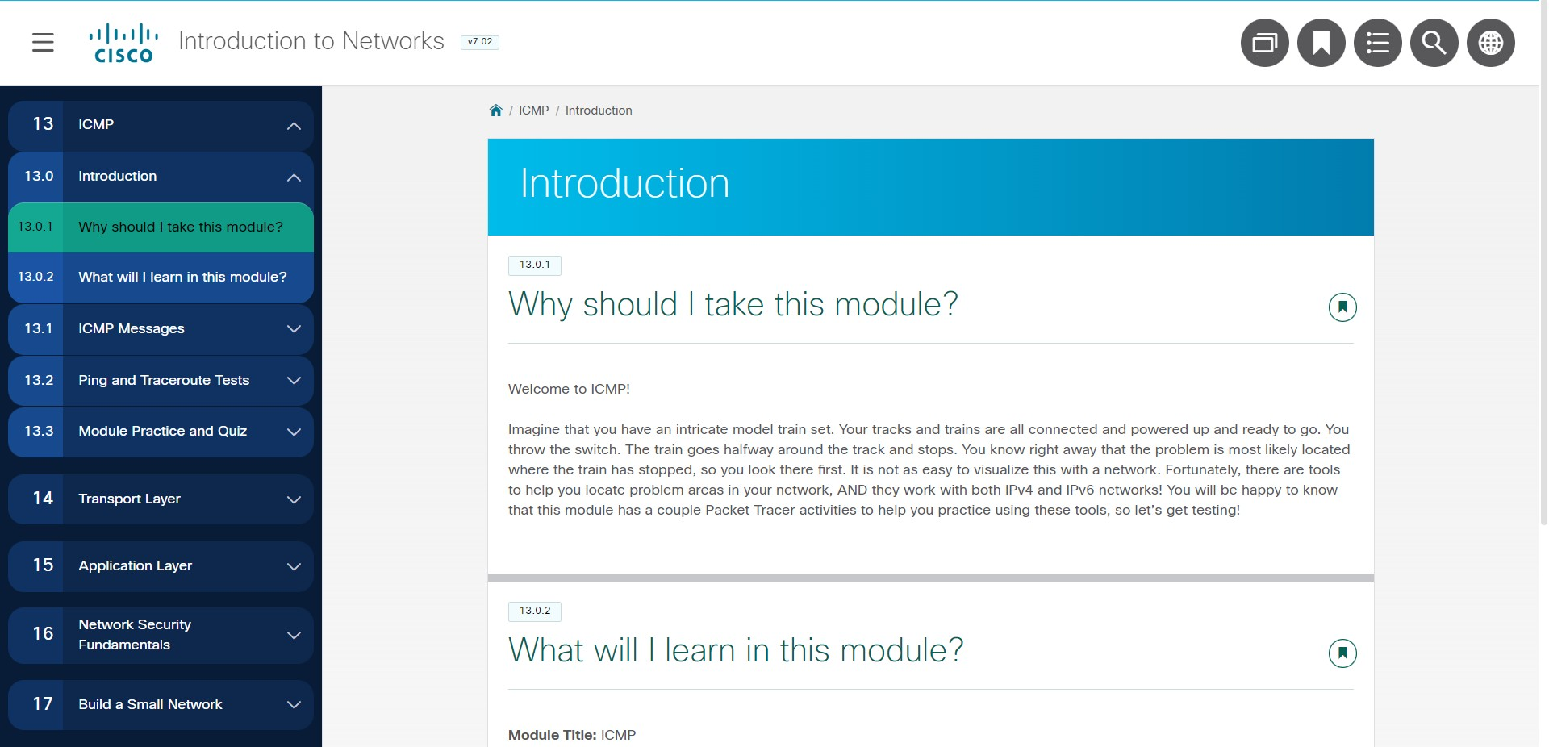

MODULE

13:

ICMP

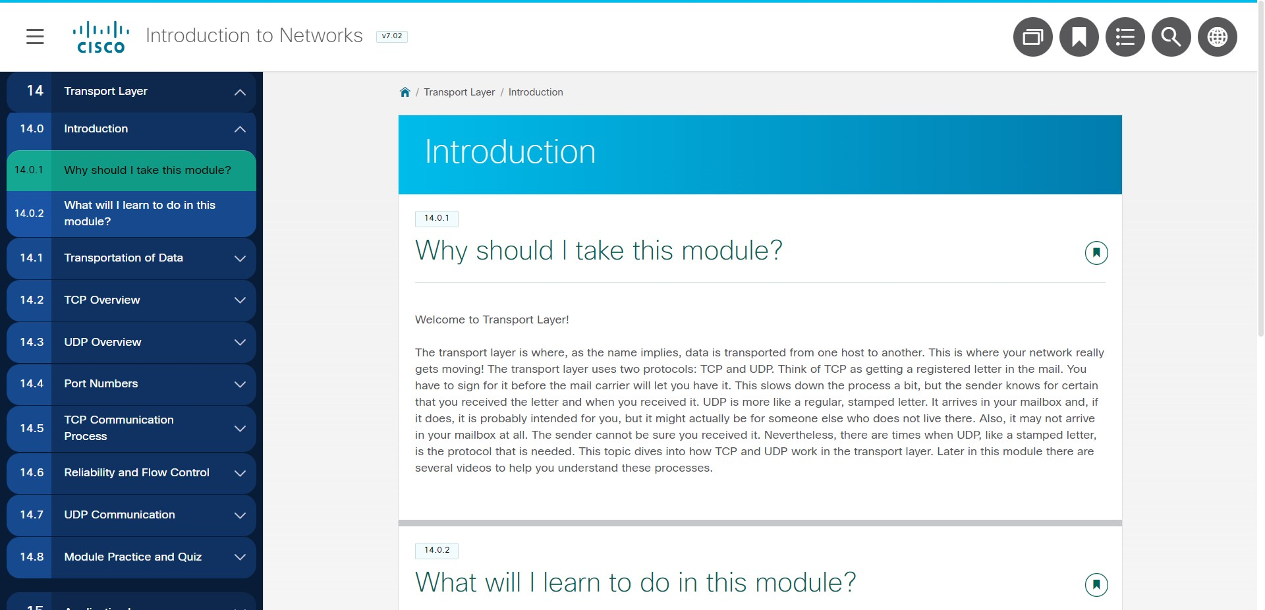

MODULES 14 - 15: NETWORK APPLICATION

COMMUNICATIONS

MODULE

14:

TRANSPORT LAYER

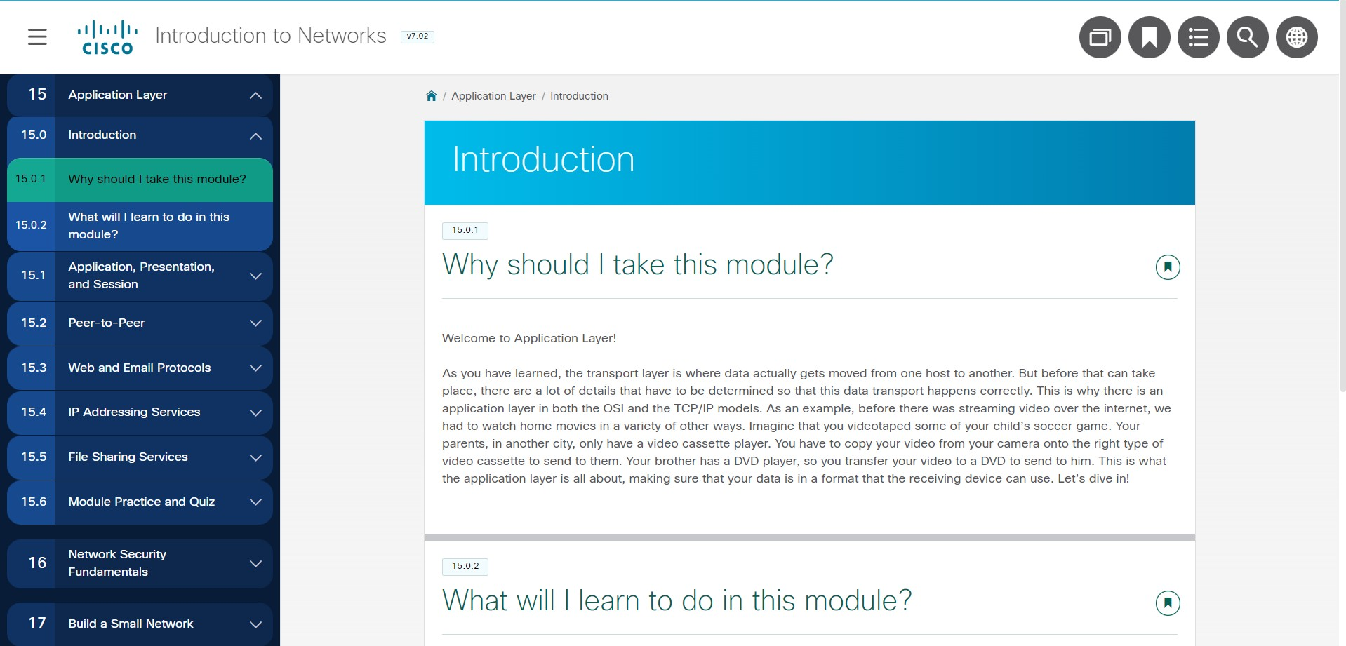

MODULE

15:

APPLICATION LAYER

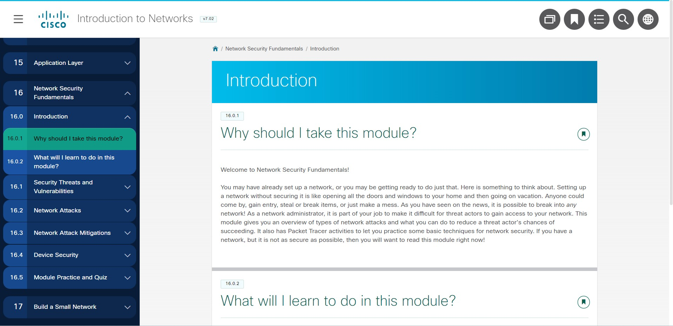

MODULES 16 - 17: BUILDING AND SECURING A

SMALL NETWORK

MODULE

16: NETWORK SECURITY FUNDAMENTALS

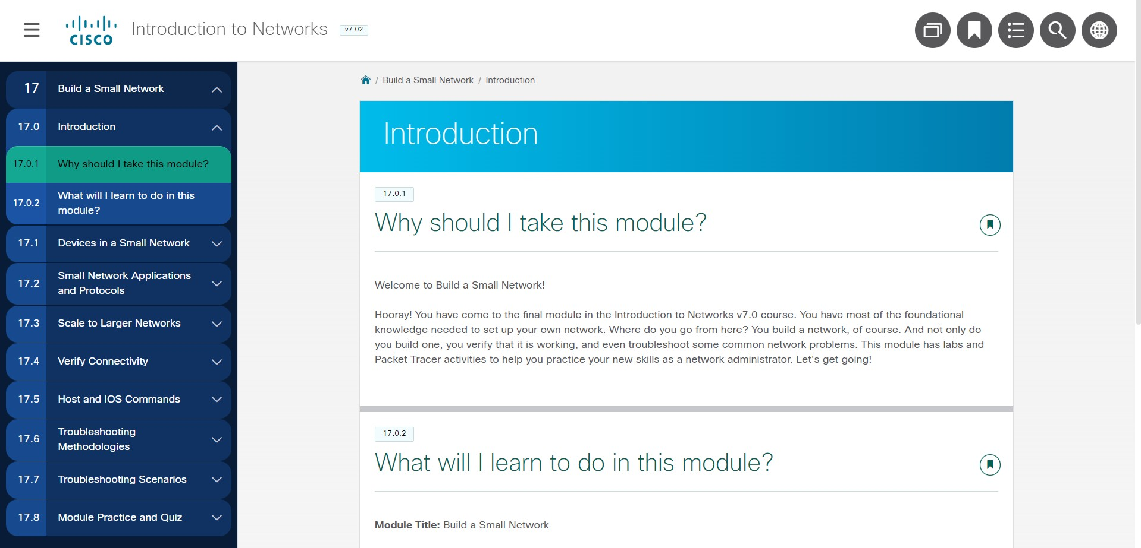

MODULE

17:

BUILD A SMALL NETWORK

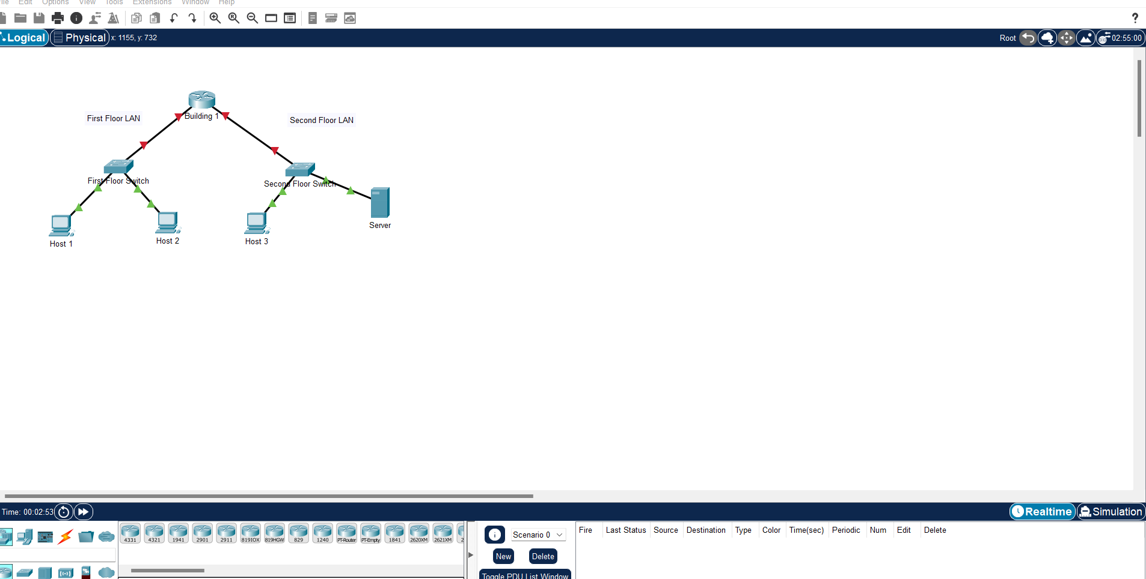

PRACTICE EXAM:

PRACTICE PT SKILL ASSESSMENT (PTSA)

1

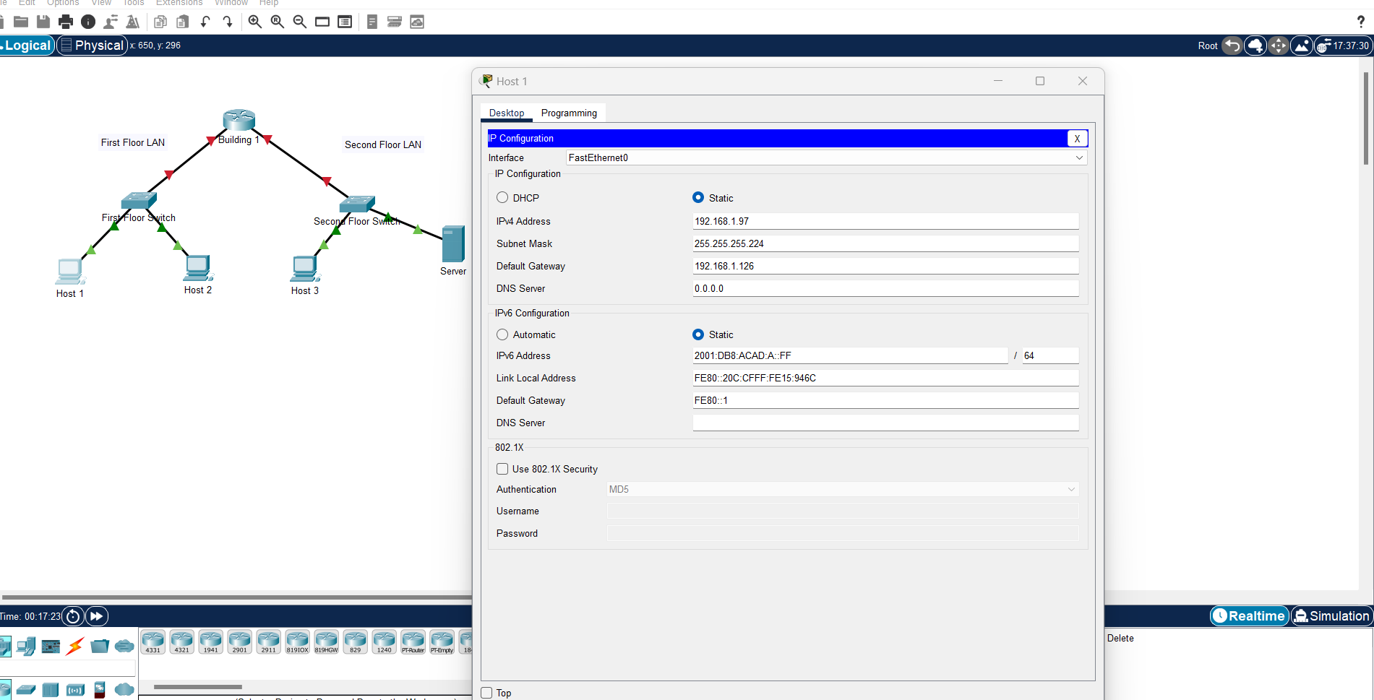

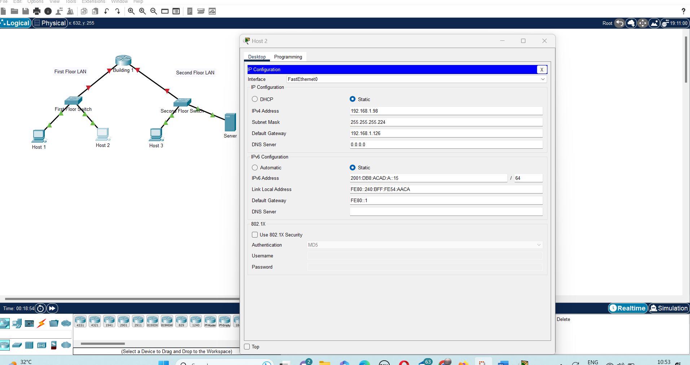

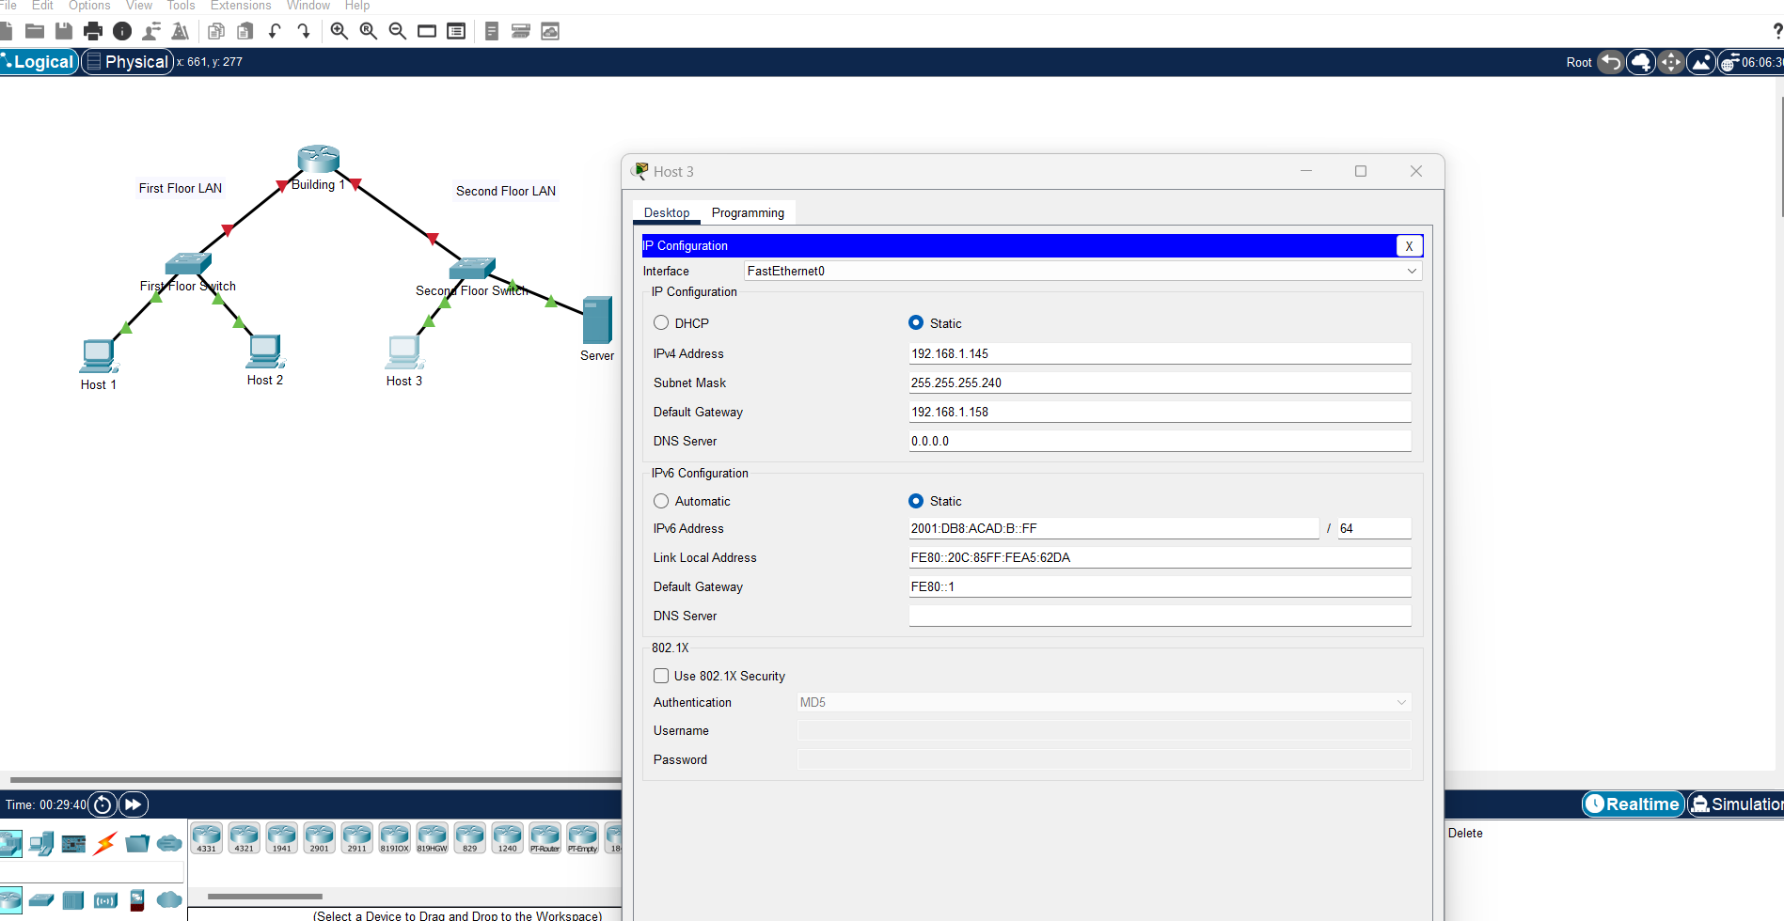

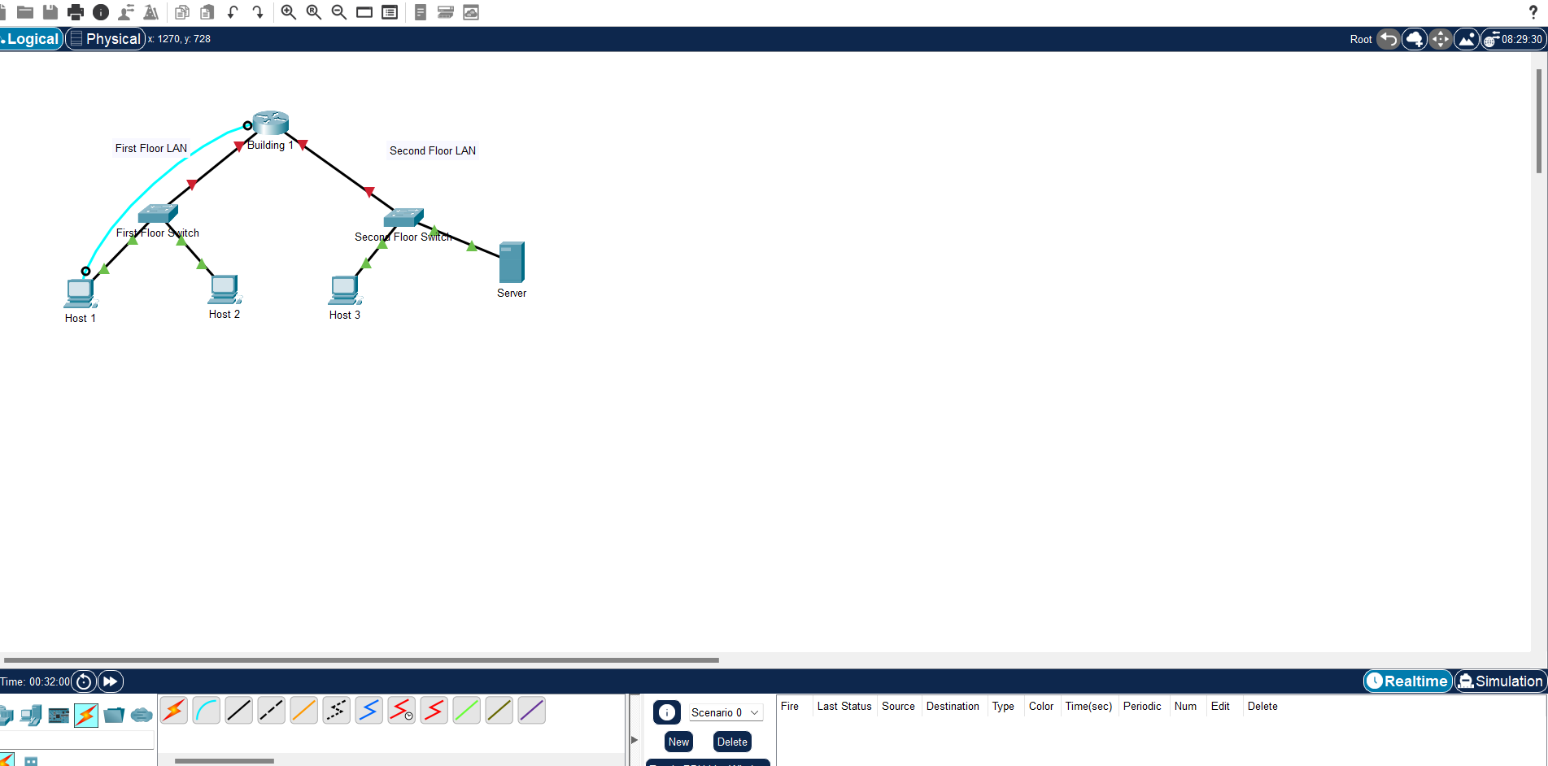

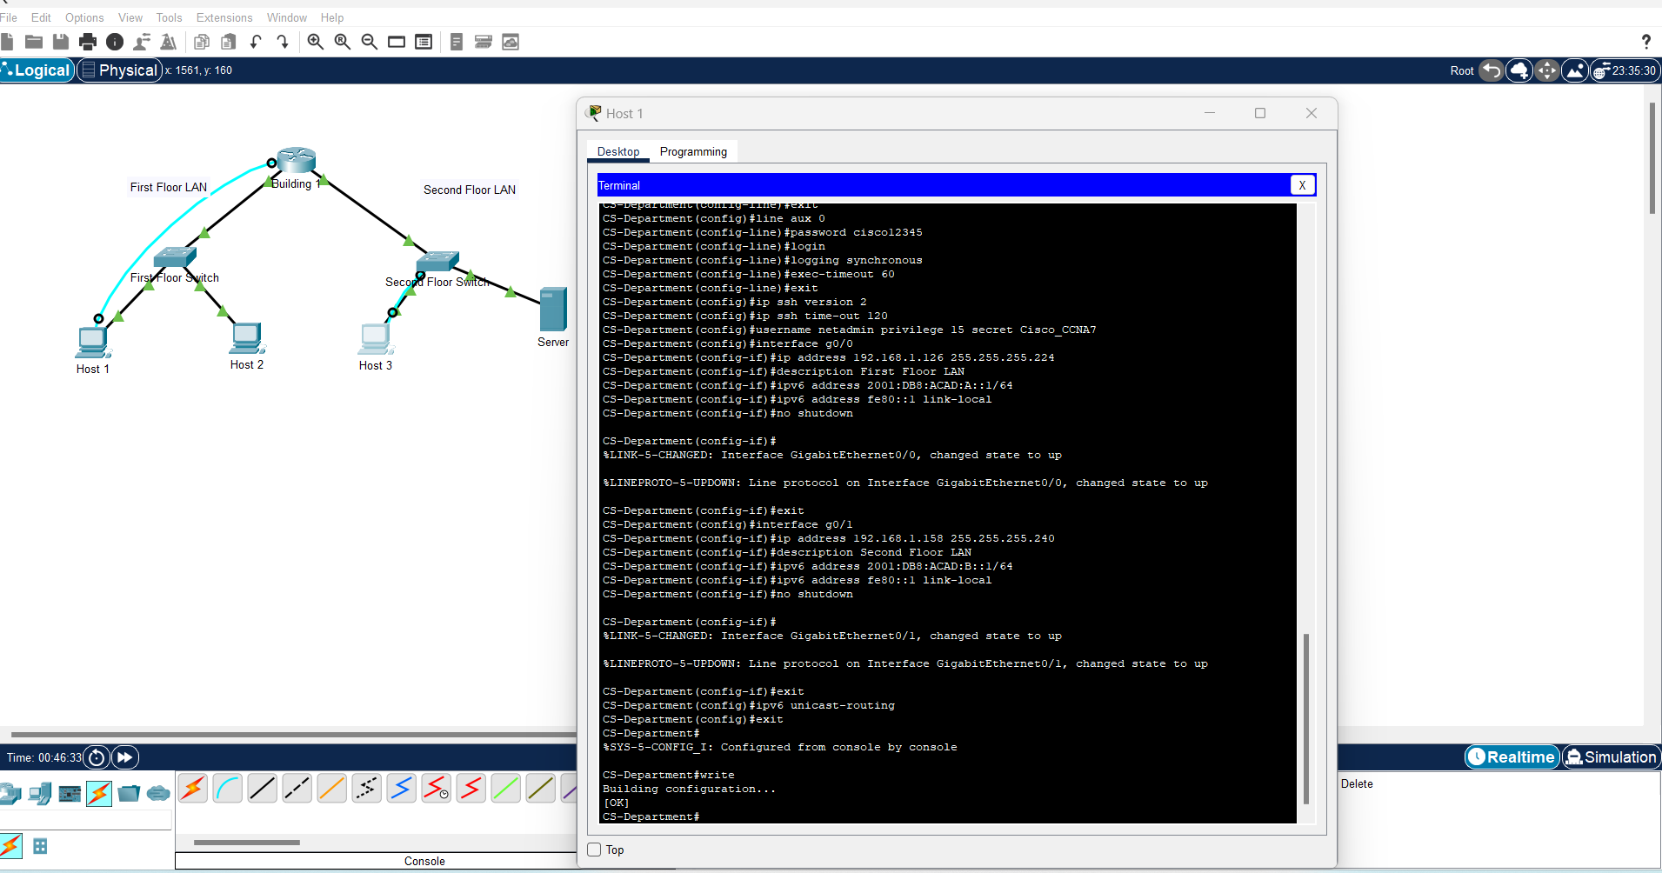

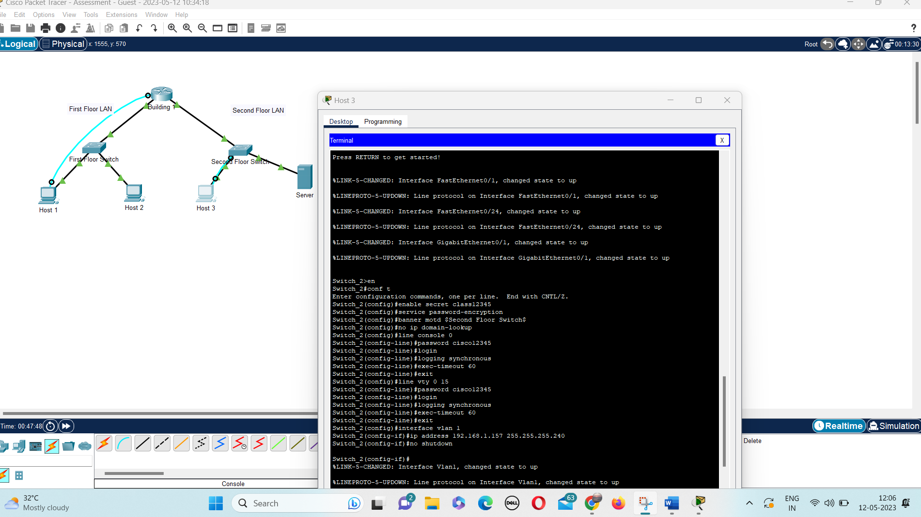

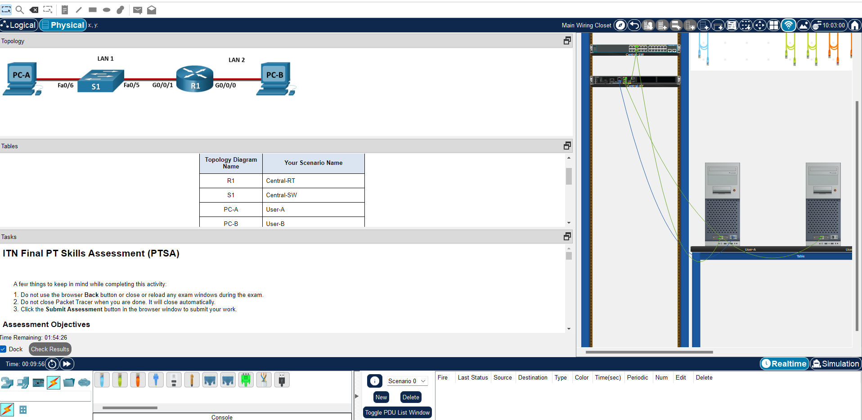

PTSA-3

